User Manual for

ShopGoodWill.com Web Mining

Qiman Wang

# 1.0. Introduction

## 1.1. Purpose

The purpose of this software is to extract useful data from [www.ShopGoodWill.com](http://www.ShopGoodWill.com) and store it for useful querying and evaluation of media in an inventory.

## 1.2. Scope of Program

This program will take user’s input and search goodwill for information on products best matched. Then stores the Item Number, Item Name, Number of Bids, Seller, Price, End Bid Date and images to the database.

# 2.0. Overall Description

## 2.1 System Environment

The software is run through one main class called StartProgram which handles which form the software is ran. There is also a GoodWIllItem class to store the item, DataStorage class to hold the GoodWillItems per ItemNumber for easy lookup, JTableRow class to handle all GUI functions and UrlProccessor class which handles parsing and obtaining data.

## 3.0. Instructions

The software can be run from command line or through GUI.

## 3.1. Command Line

Open command line prompt in the .java files folder, enter in the following sequences.

You also need an in.txt file with a new item name on every line.

1. javac *.java

2. java StartProgram -i in.txt -o out.txt

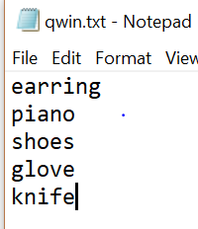

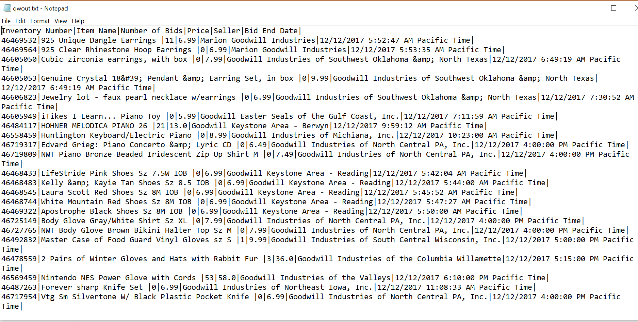

## 3.1. Normal execution

1. javac *.java

2. java StartProgram

3. Now u need to register for account and then log in.

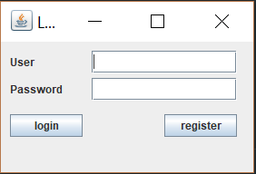

4. The top part shows the current database for that user.

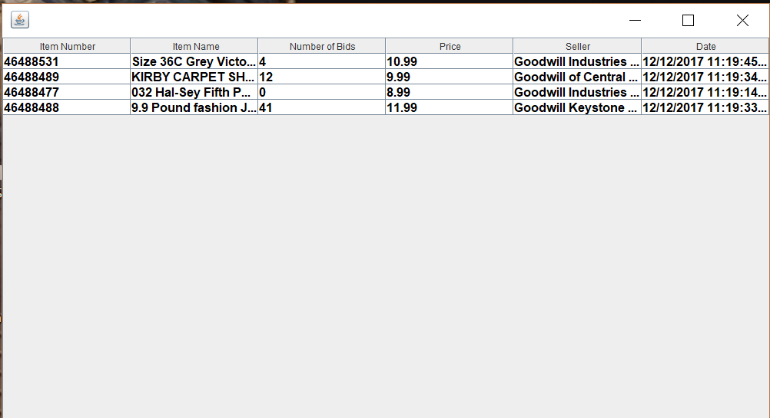

5. the bottom left part allows for manual data adding, data updating, data deleting and save to database.

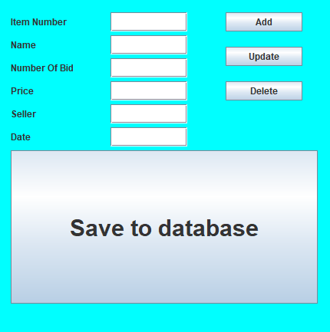

6. the bottom right part allows for data field entry and then search on goodwill.

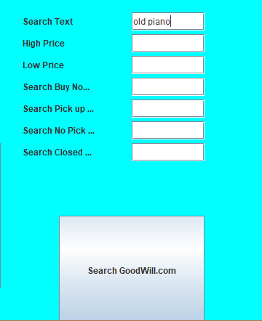

7.clicking search goodwill.com will return result and save to top view.

8.Click save to database to save.

9. closing the GUI will terminate the program.